Project title: Import Data Using Transform Maps

Phase 5: Project Development Phase

1. Target Database Custom Table Creation Steps

1. Navigated through the system backend console: Tables -> Create New.
2. Set the global table parameters: Label as Employee Test and Name auto-populated as u_employee_test.
3. Scrolled to the bottom of the newly generated form interface and activated the Show Form command option link.
4. Opened the contextual header configuration menu by clicking Additional Actions -> Configure -> Form Layout.
5. Created and saved 5 dedicated fields matching the specification requirements: Employee ID, Employee Name, Email, Department, and Location, all set as standard String configurations.

2. Data Ingestion Staging Area Provisioning Steps

1. Entered the path into the platform search navigator: System Import Sets -> Load Data.
2. Configured the parameters to create a new import staging table named Employee Import (u_employee_import).
3. Selected the local file payload choice, browsed to Sample Spreadsheet.xlsx, and submitted the file to the ingestion engine.

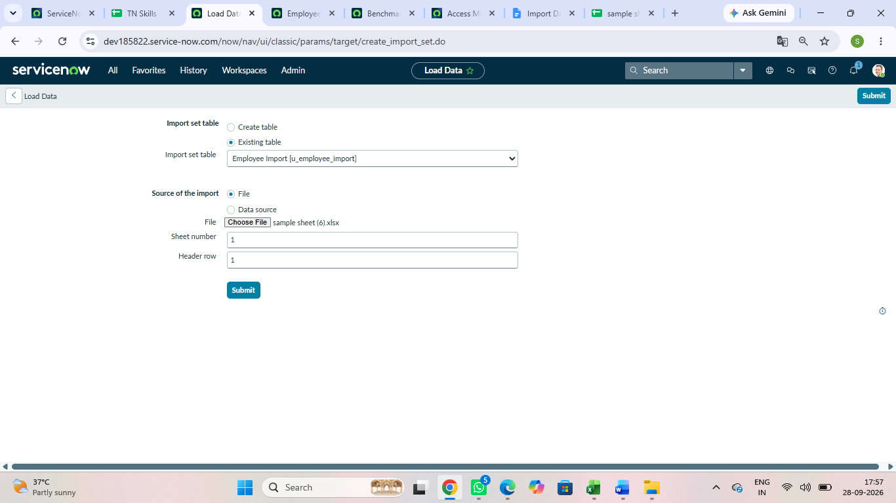

3. Transform Mapping Engine Configuration Steps

1. Clicked the successful notification shortcut link named Create Transform Map.
2. Specified the routing parameters: Name set to Sample Spreadsheet Import, Source configured as u_employee_import, and Target mapped to u_employee_test.
3. Executed the platform automated utility Auto Map Matching Fields to map identical columns instantly.
4. Opened Mapping Assist to manually map columns and align the source data directly with our target table fields.
5. Saved the configurations and clicked the Transform action button to process the initial data load.

